Decorative Freeform Shapes
# Source: AI Source: Provided by: [Data Path: Persons Table -> ID Column: 1, Name_En Column: Motasem Essam] -> From: [ChatGPT] on [7/25/2026]
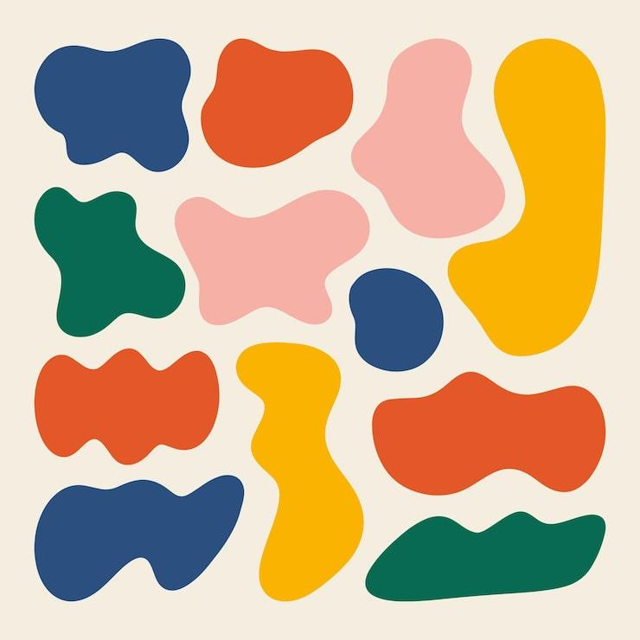
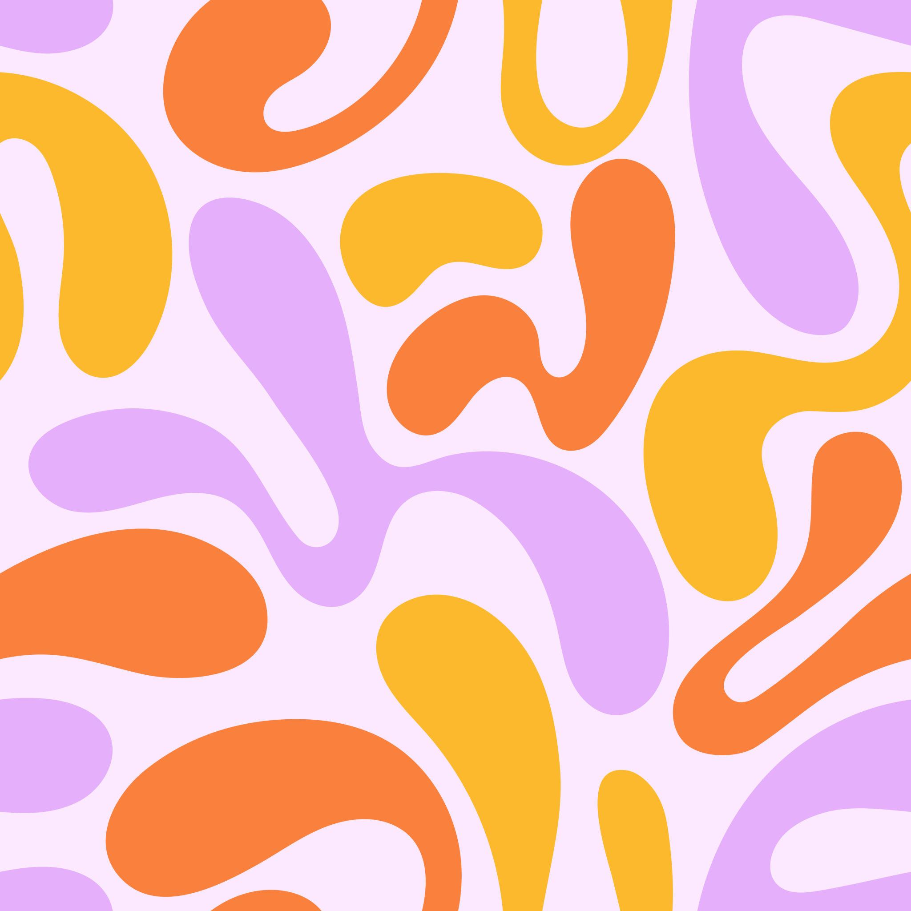
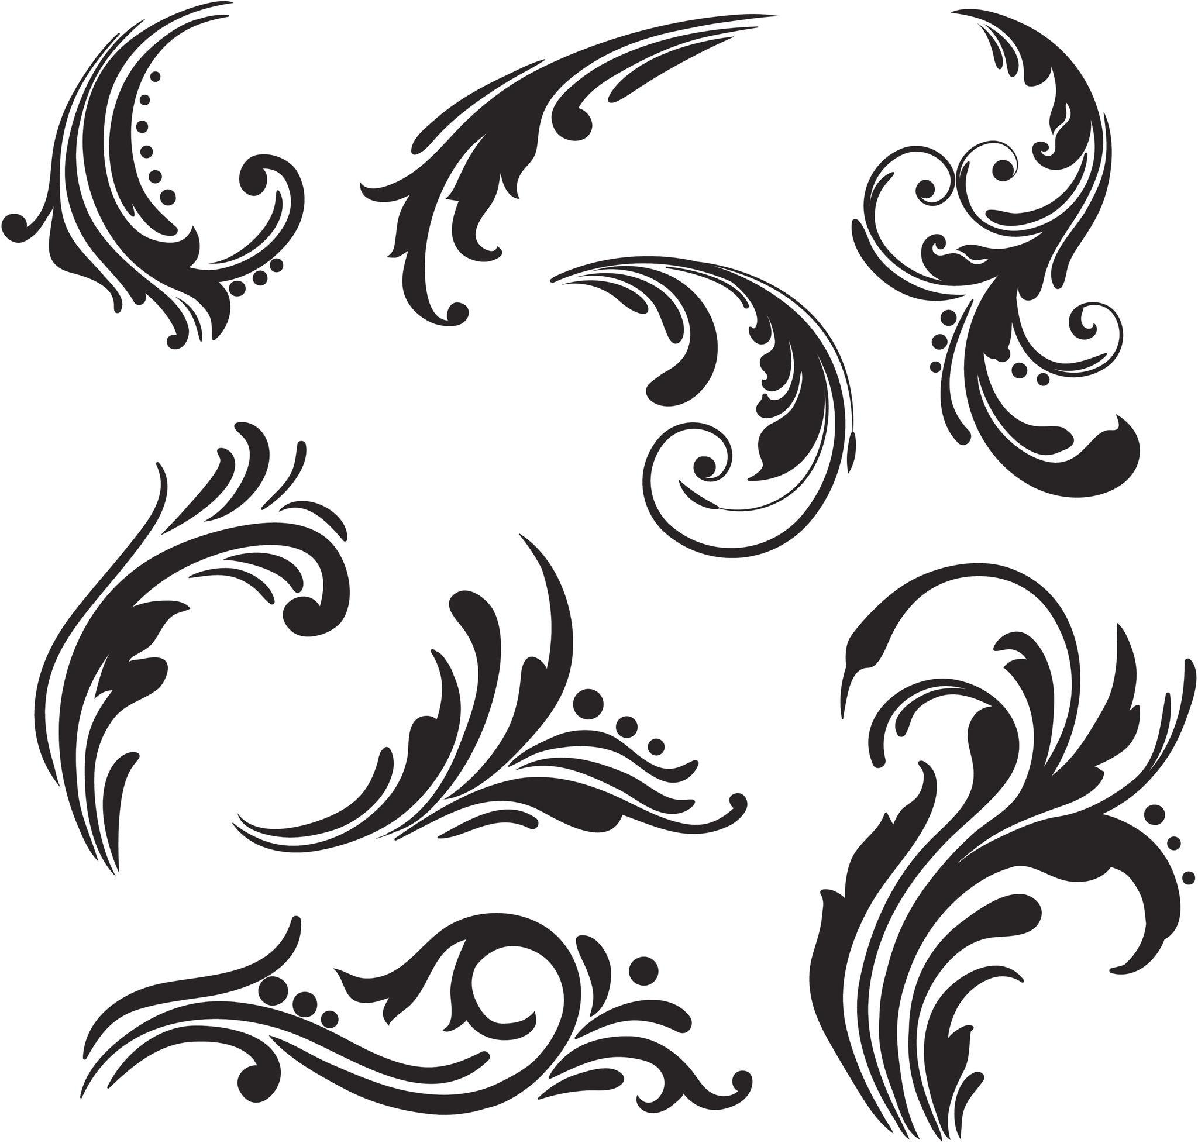
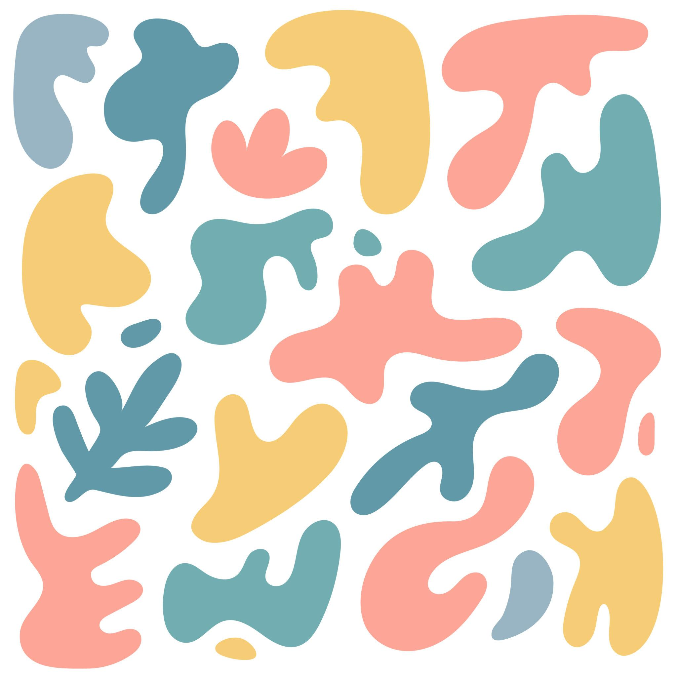
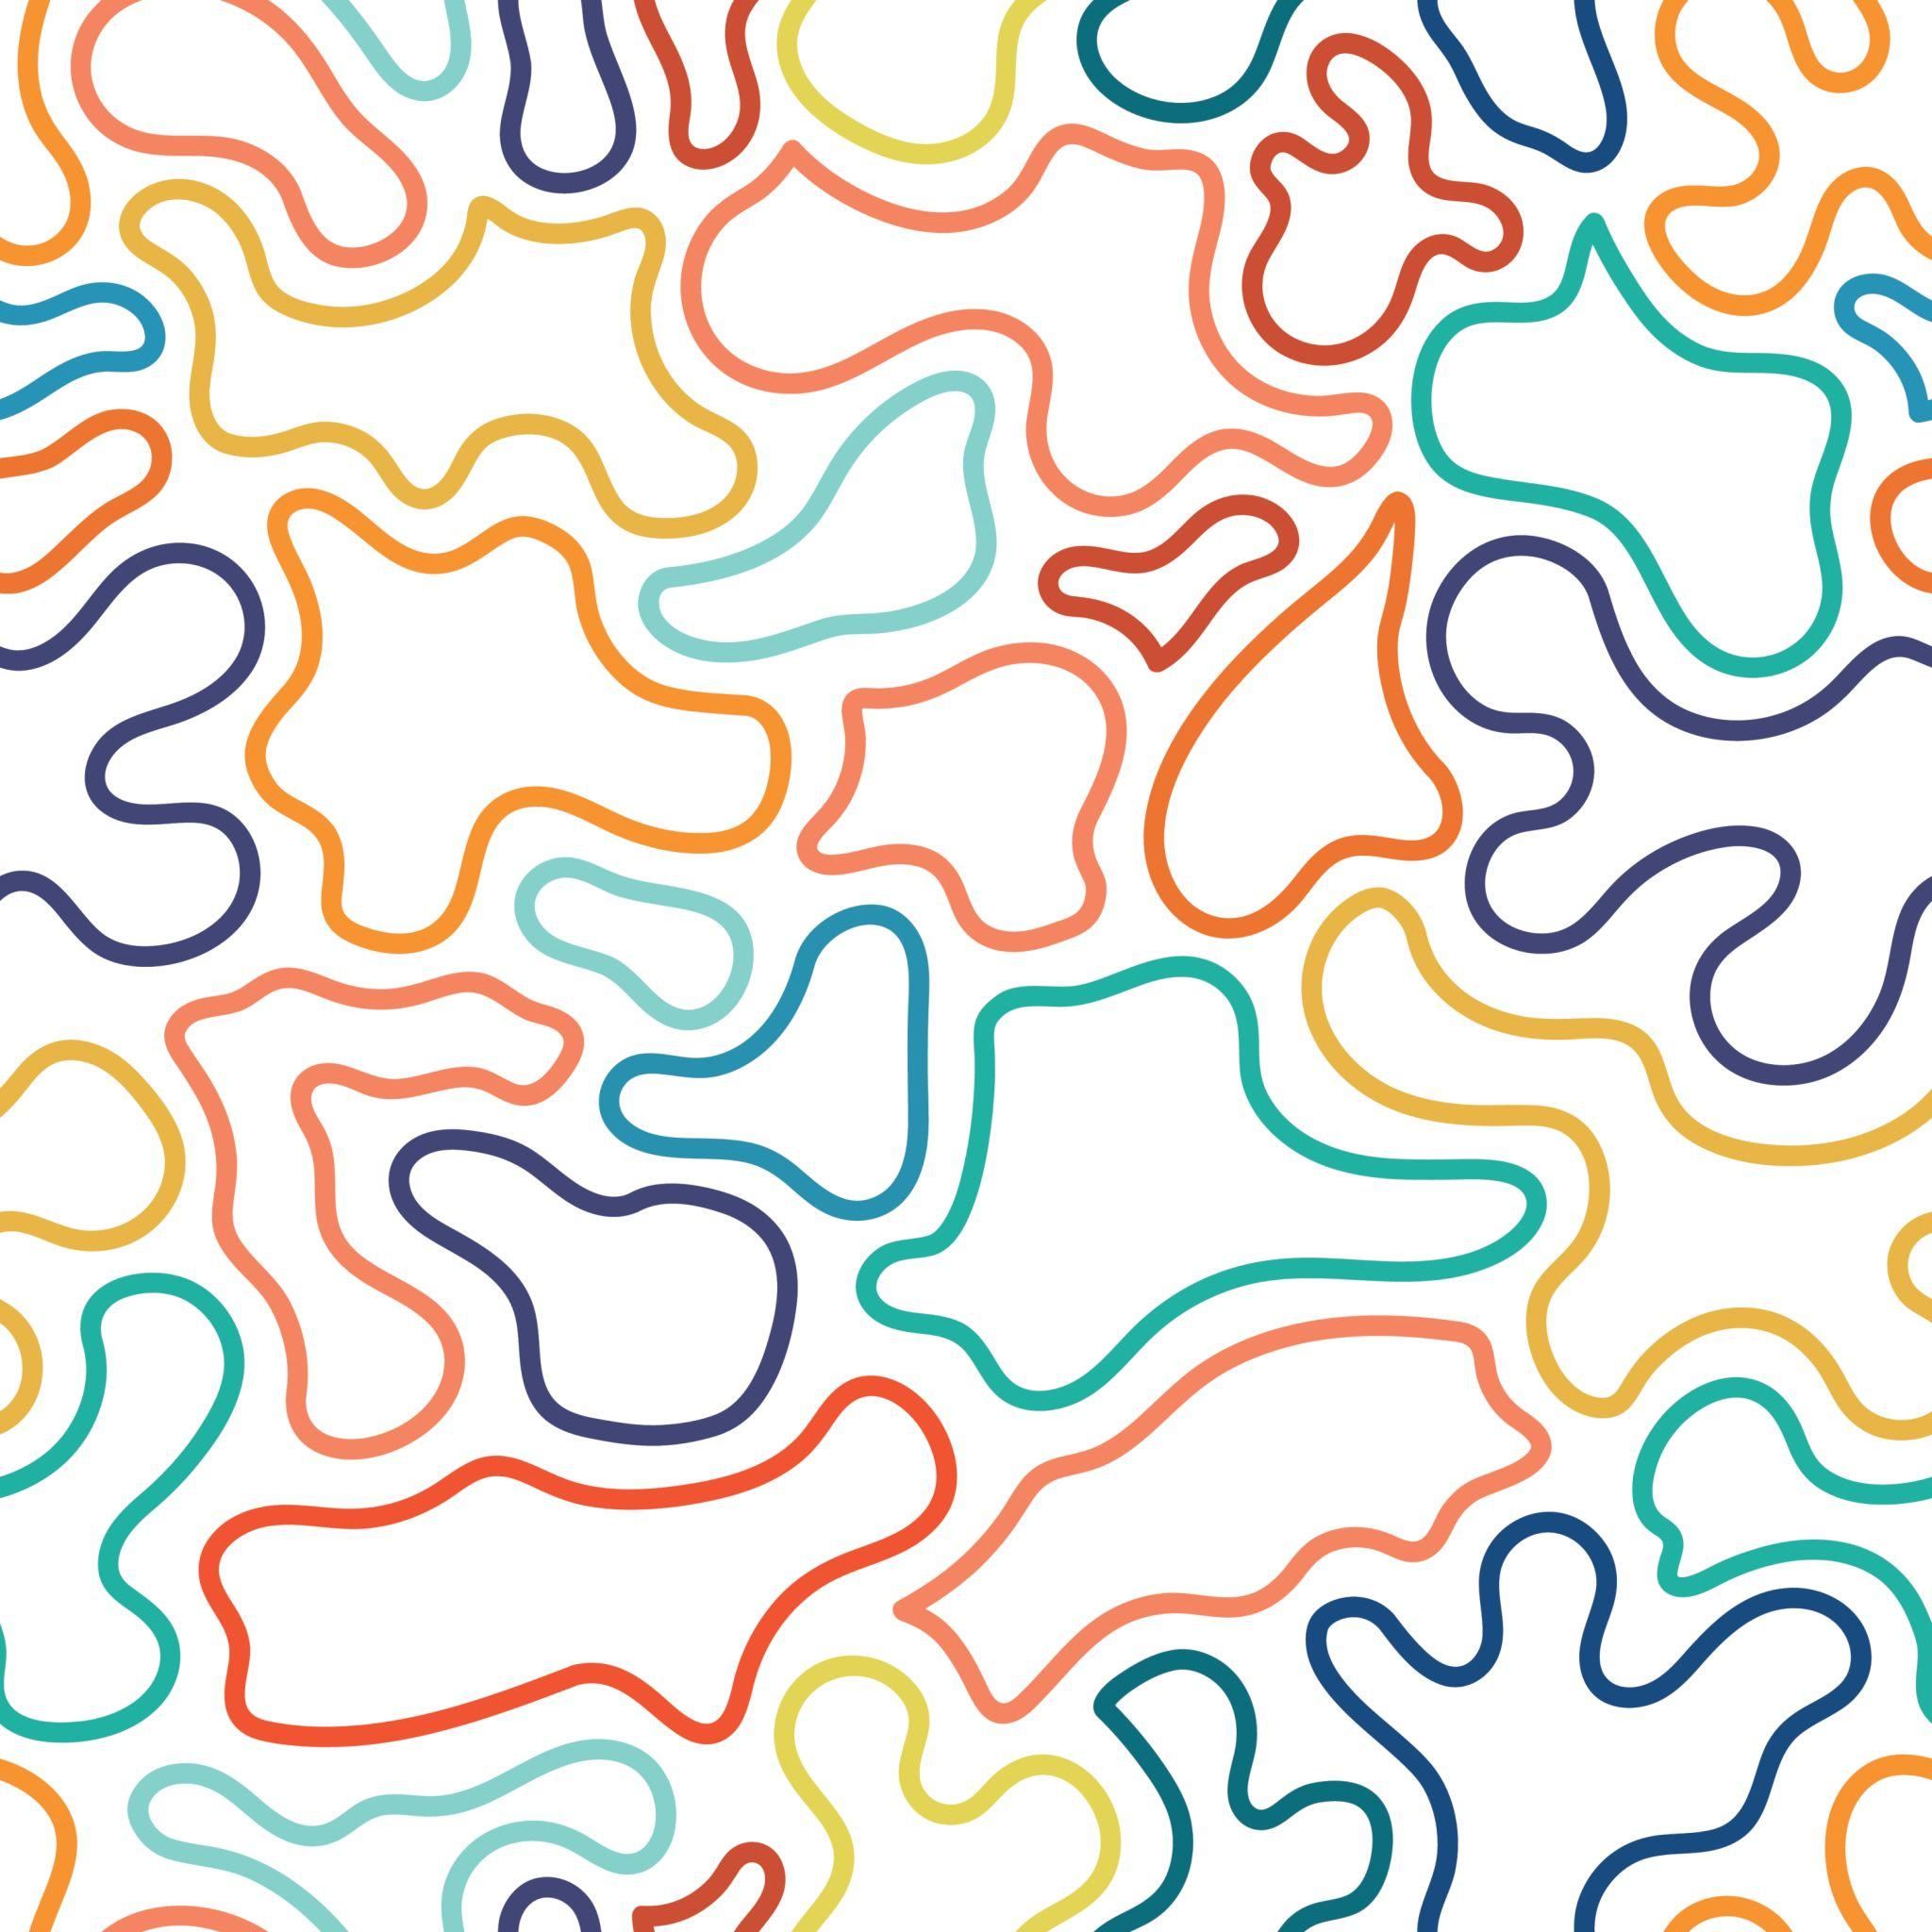
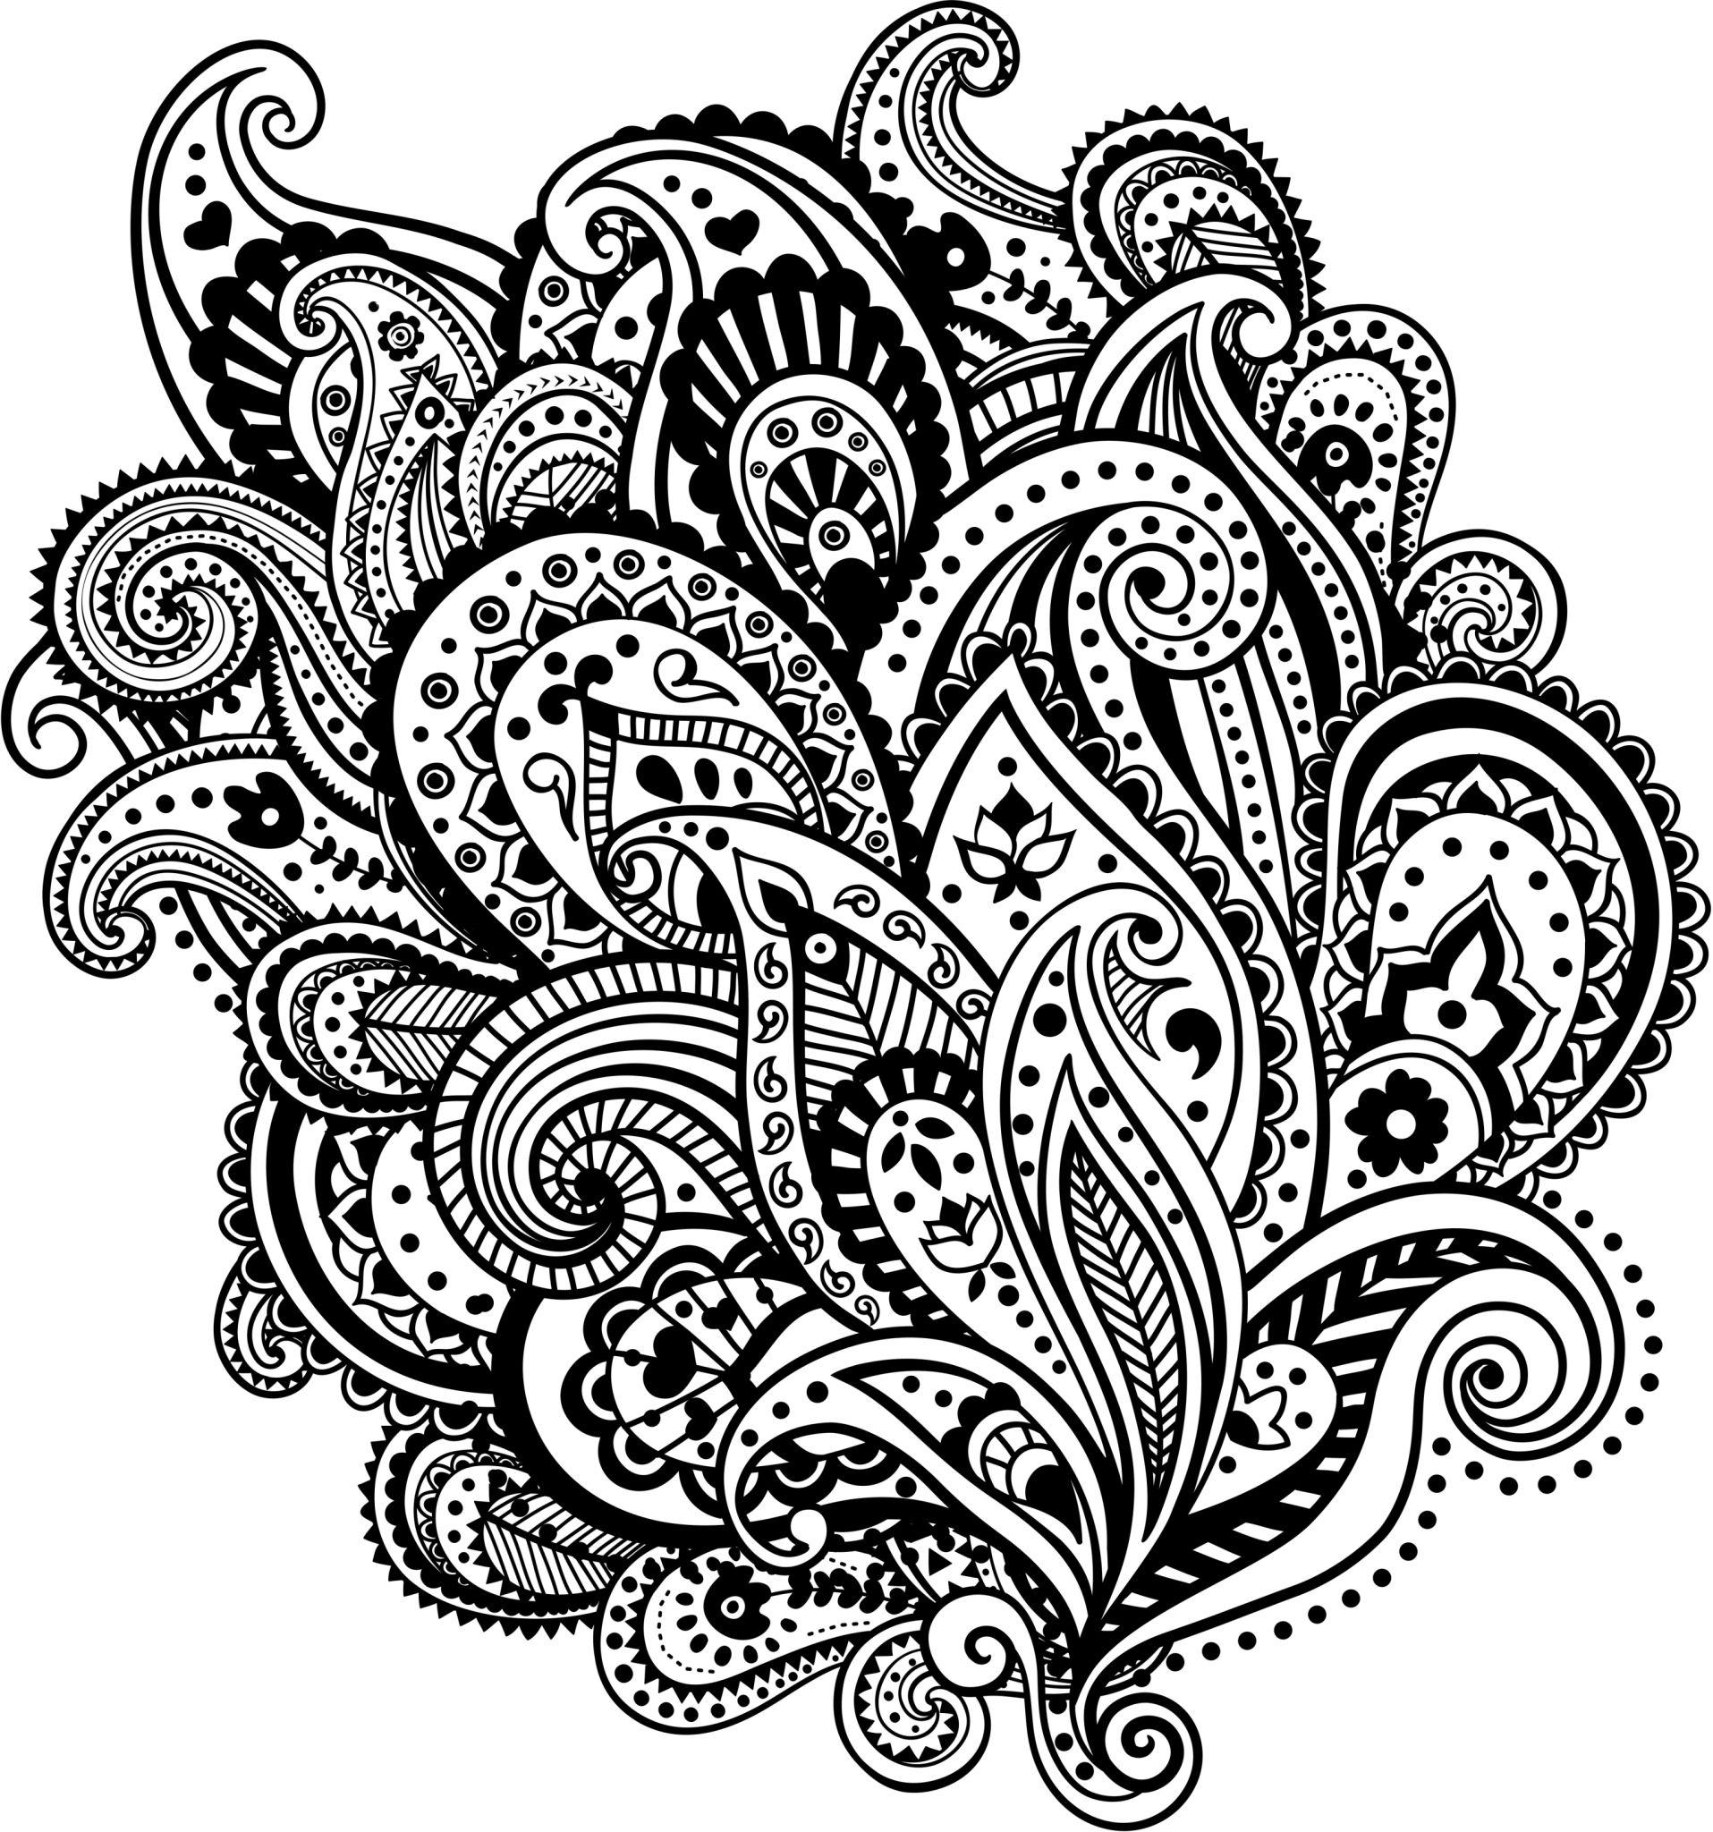

Definition
# Source: AI Source: Provided by: [Data Path: Persons Table -> ID Column: 1, Name_En Column: Motasem Essam] -> From: [ChatGPT] on [7/25/2026]
Decorative Freeform Shapes are freeform shapes designed primarily for visual, ornamental, or aesthetic purposes rather than to represent a standard geometric figure or perform a specific geometric function.
They may combine:
- Curves
- Straight lines
- Irregular boundaries
- Repeated motifs
- Organic forms
- Abstract forms
- Symmetric or asymmetric elements
The term combines two characteristics:
Freeform → the shape is not restricted to a fixed standard geometric form.
Decorative → the shape is primarily intended to enhance visual appearance or ornamentation.

Fundamental Concept
# Source: AI Source: Provided by: [Data Path: Persons Table -> ID Column: 1, Name_En Column: Motasem Essam] -> From: [ChatGPT] on [7/25/2026]
The defining idea is:
A Decorative Freeform Shape is a non-standard shape whose design is primarily intended to create an ornamental or visually expressive effect.
For example, a decorative border may use flowing curves and irregular elements without corresponding to a specific polygon, circle, or other standard geometric figure.
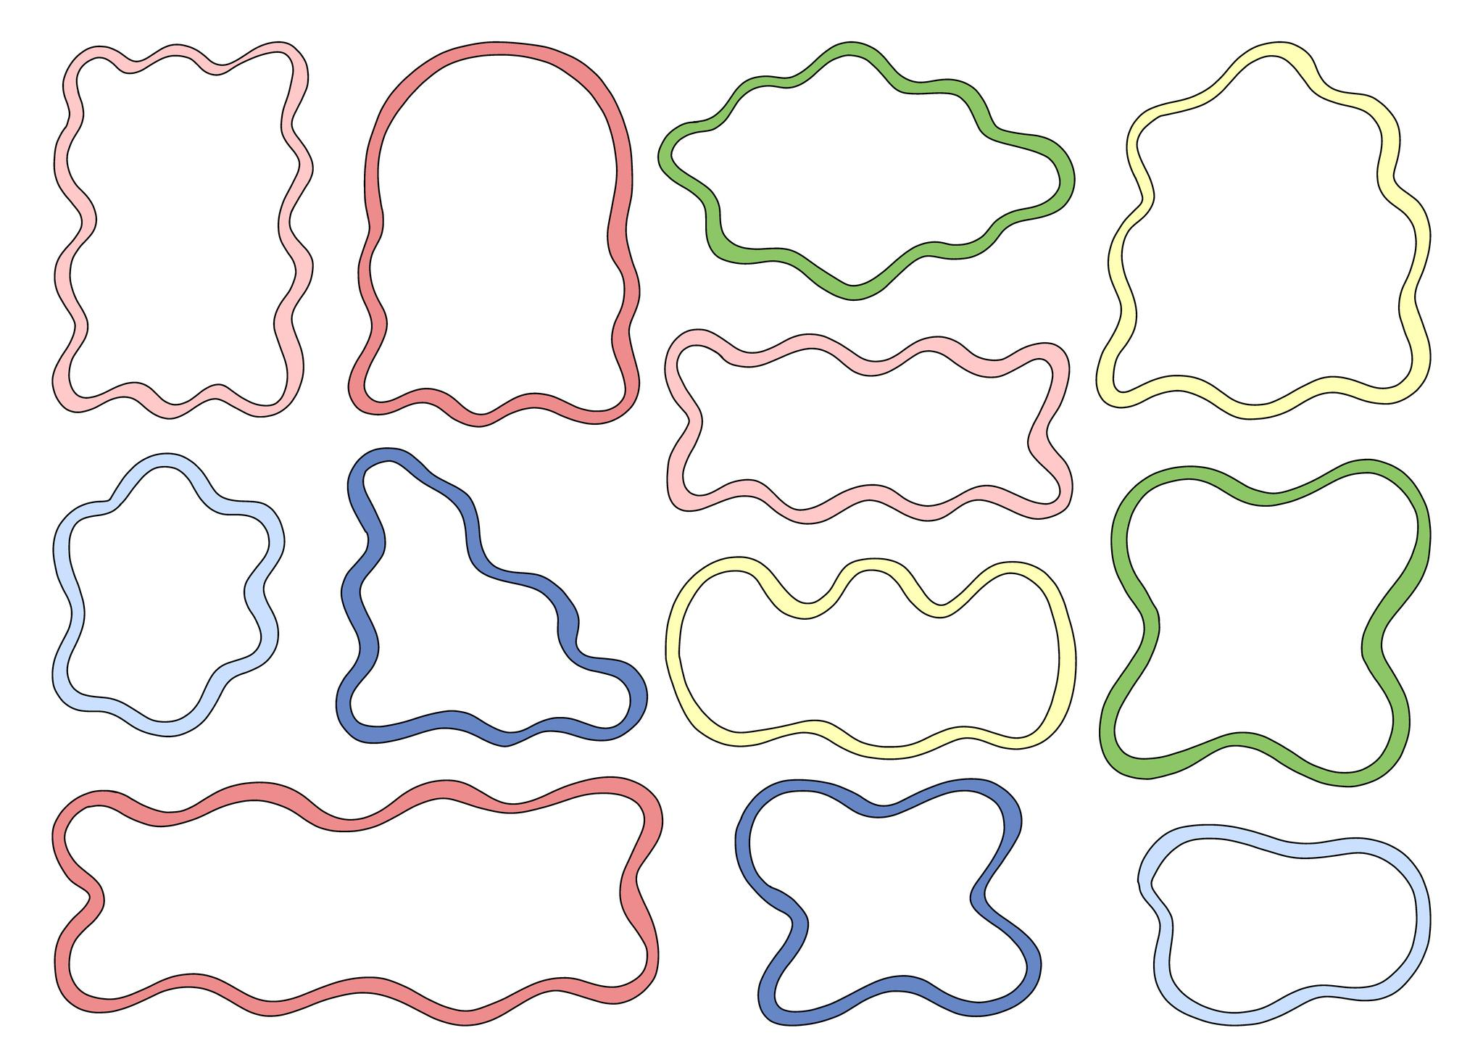
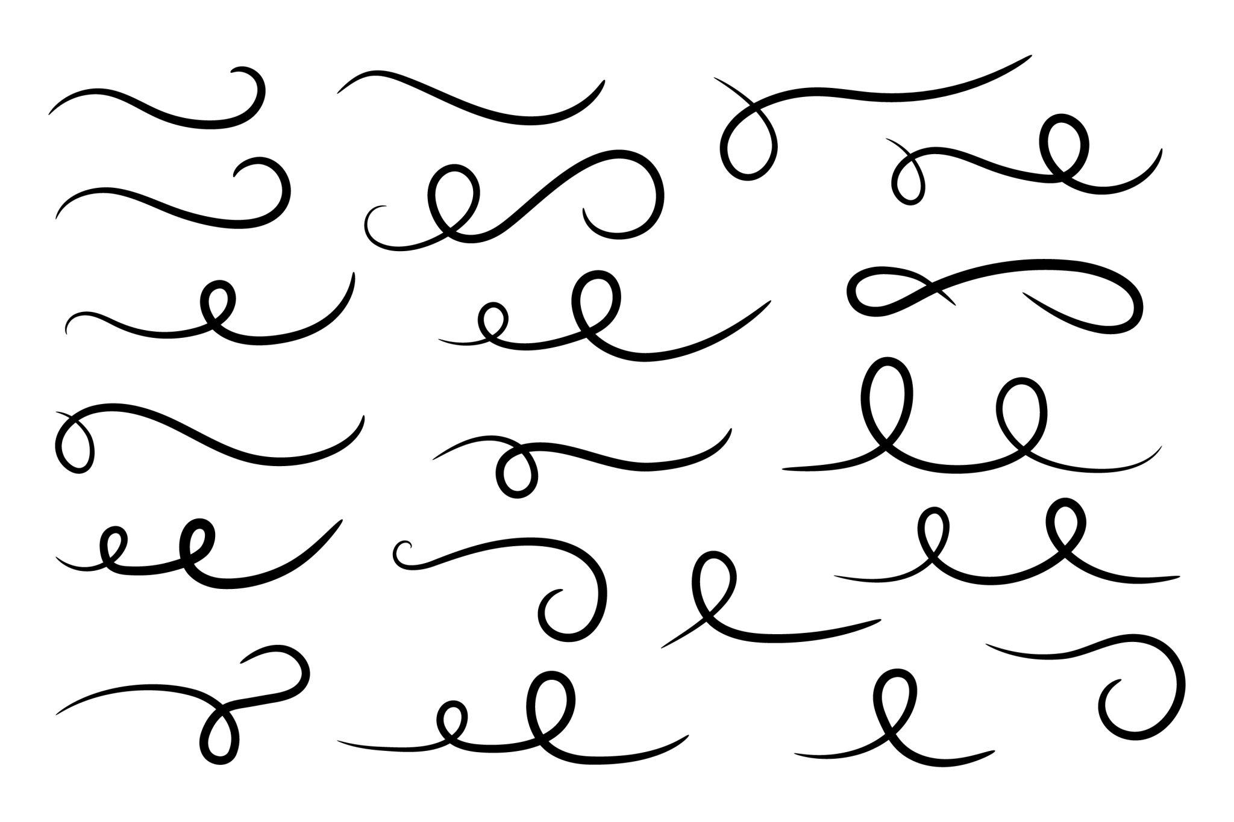
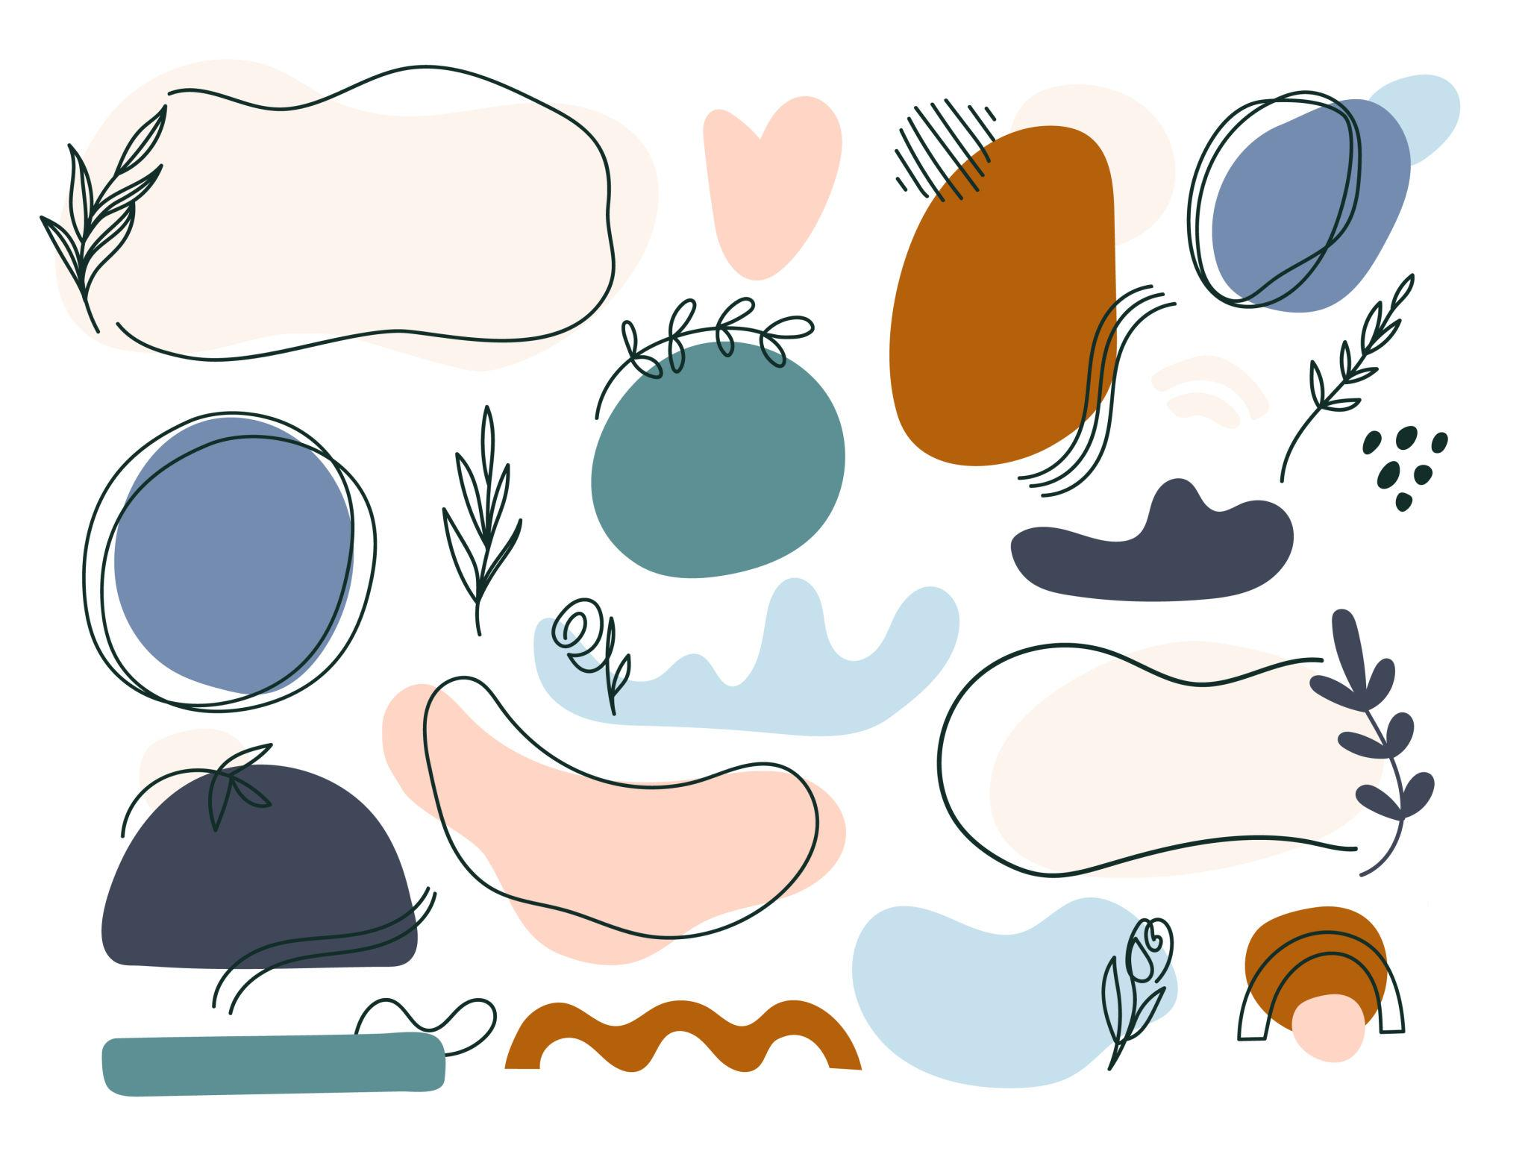
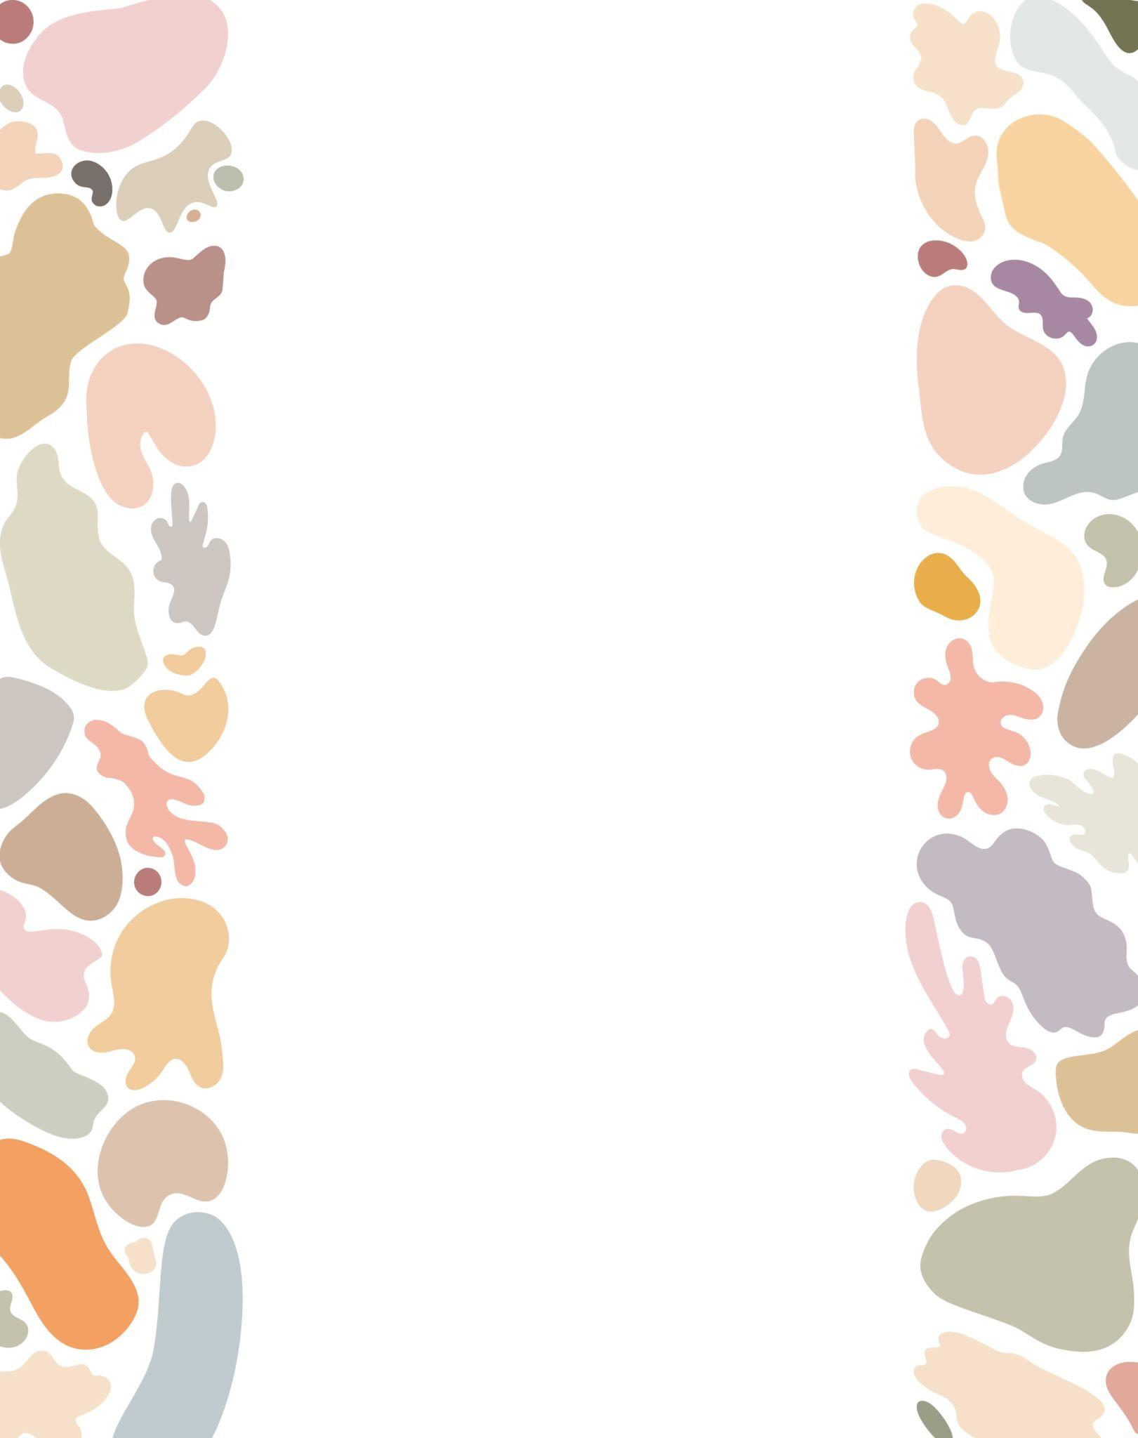
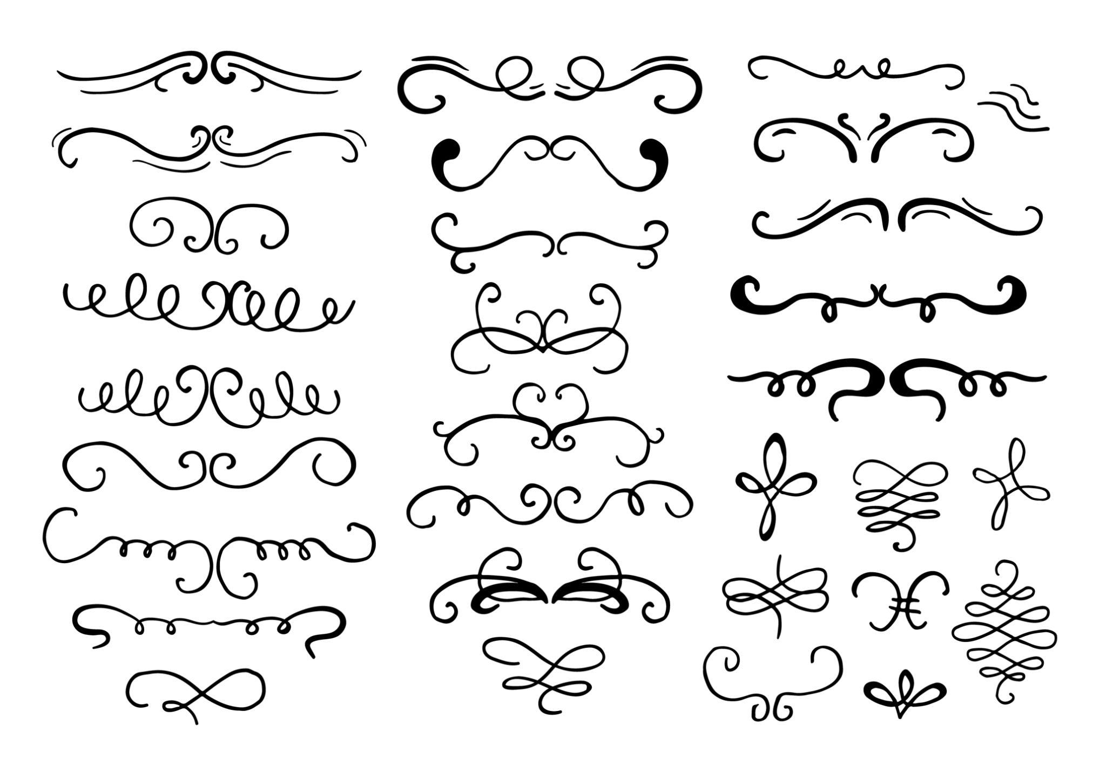

Main Characteristics
# Source: AI Source: Provided by: [Data Path: Persons Table -> ID Column: 1, Name_En Column: Motasem Essam] -> From: [ChatGPT] on [7/25/2026]
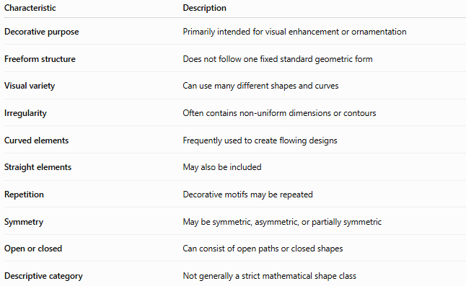
Characteristic | Description
Decorative purpose | Primarily intended for visual enhancement or ornamentation
Freeform structure | Does not follow one fixed standard geometric form
Visual variety | Can use many different shapes and curves
Irregularity | Often contains non-uniform dimensions or contours
Curved elements | Frequently used to create flowing designs
Straight elements | May also be included
Repetition | Decorative motifs may be repeated
Symmetry | May be symmetric, asymmetric, or partially symmetric
Open or closed | Can consist of open paths or closed shapes
Descriptive category | Not generally a strict mathematical shape class

Basic Structure
# Source: AI Source: Provided by: [Data Path: Persons Table -> ID Column: 1, Name_En Column: Motasem Essam] -> From: [ChatGPT] on [7/25/2026]
Decorative Freeform Shapes can be constructed from several types of elements:
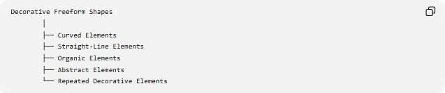
Decorative Freeform Shapes
│
├── Curved Elements
├── Straight-Line Elements
├── Organic Elements
├── Abstract Elements
└── Repeated Decorative Elements
A decorative design may consist of a single freeform shape or a collection of related shapes.

Types of Decorative Freeform Shapes
# Source: AI Source: Provided by: [Data Path: Persons Table -> ID Column: 1, Name_En Column: Motasem Essam] -> From: [ChatGPT] on [7/25/2026]
A useful descriptive classification is:
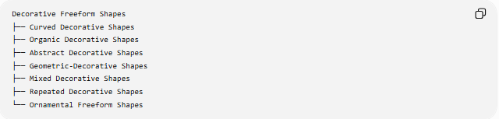
Decorative Freeform Shapes
├── Curved Decorative Shapes
├── Organic Decorative Shapes
├── Abstract Decorative Shapes
├── Geometric-Decorative Shapes
├── Mixed Decorative Shapes
├── Repeated Decorative Shapes
└── Ornamental Freeform Shapes
These categories can overlap.
For example, a repeated decorative design can simultaneously be:
Curved + Organic + Symmetric + Repeated + Decorative

Curved Decorative Shapes
# Source: AI Source: Provided by: [Data Path: Persons Table -> ID Column: 1, Name_En Column: Motasem Essam] -> From: [ChatGPT] on [7/25/2026]
Shapes primarily composed of flowing or irregular curves.
They may contain:
- Arcs
- Waves
- Spirals
- Loops
- Smooth curves
- Irregular curves
Their purpose is primarily visual rather than mathematical.

Organic Decorative Shapes
# Source: AI Source: Provided by: [Data Path: Persons Table -> ID Column: 1, Name_En Column: Motasem Essam] -> From: [ChatGPT] on [7/25/2026]
Decorative shapes inspired by natural forms.
Examples include forms resembling:
- Leaves
- Flowers
- Vines
- Petals
- Waves
- Clouds
They often combine natural-looking curves with decorative repetition.

Abstract Decorative Shapes
# Source: AI Source: Provided by: [Data Path: Persons Table -> ID Column: 1, Name_En Column: Motasem Essam] -> From: [ChatGPT] on [7/25/2026]
Shapes that do not represent a specific recognizable object.
They may use:
- Irregular curves
- Angular sections
- Unusual proportions
- Abstract patterns
- Non-standard combinations
Their main purpose is visual expression or ornamentation.

Geometric-Decorative Shapes
# Source: AI Source: Provided by: [Data Path: Persons Table -> ID Column: 1, Name_En Column: Motasem Essam] -> From: [ChatGPT] on [7/25/2026]
These use recognizable geometric elements as part of a decorative composition.
Examples include combinations of:
- Circles
- Arcs
- Polygons
- Stars
- Spirals
- Lines
The individual components may be geometric, while the overall decorative arrangement is freeform.

Mixed Decorative Shapes
# Source: AI Source: Provided by: [Data Path: Persons Table -> ID Column: 1, Name_En Column: Motasem Essam] -> From: [ChatGPT] on [7/25/2026]
Shapes that combine several different types of elements.
For example:
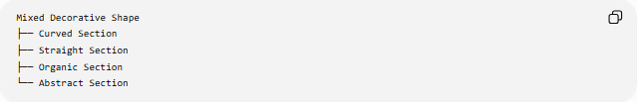
Mixed Decorative Shape
├── Curved Section
├── Straight Section
├── Organic Section
└── Abstract Section
The mixture gives the design a more varied visual structure.

Repeated Decorative Shapes
# Source: AI Source: Provided by: [Data Path: Persons Table -> ID Column: 1, Name_En Column: Motasem Essam] -> From: [ChatGPT] on [7/25/2026]
Shapes or motifs that are repeated to create a decorative pattern.
Repetition may occur through:
- Translation
- Rotation
- Reflection
- Scaling
- Alternation
For example, a single freeform motif can be repeated along a line or around a center.
If a motif $S$is translated by vector $v$, its copies can be represented as:
$$S_{n}=S+nv$$
for appropriate integer values of $n$.

Ornamental Freeform Shapes
# Source: AI Source: Provided by: [Data Path: Persons Table -> ID Column: 1, Name_En Column: Motasem Essam] -> From: [ChatGPT] on [7/25/2026]
Shapes specifically designed as ornamentation.
They may appear in:
- Borders
- Frames
- Decorative panels
- Illustrations
- Logos
- Surface designs
- Architectural ornament
They often combine multiple freeform elements into a visually coherent composition.

Open and Closed Decorative Freeform Shapes

Open Decorative Freeform Shapes
# Source: AI Source: Provided by: [Data Path: Persons Table -> ID Column: 1, Name_En Column: Motasem Essam] -> From: [ChatGPT] on [7/25/2026]
An open decorative shape has two endpoints and does not enclose a region.
Examples include:
- Decorative lines
- Flourishes
- Curved ornaments
- Vines
- Decorative strokes
A parametric representation can be written as:
$$r\left(t\right)=\left(x , \left(t\right)y\left(t\right)\right)$$
with:
$$r\left(a\right)≠r\left(b\right)$$

Closed Decorative Freeform Shapes
# Source: AI Source: Provided by: [Data Path: Persons Table -> ID Column: 1, Name_En Column: Motasem Essam] -> From: [ChatGPT] on [7/25/2026]
A closed decorative shape returns to its starting point:
$$r\left(a\right)=r\left(b\right)$$
and therefore forms an enclosed boundary.
Examples include:
- Decorative frames
- Ornamental medallions
- Floral-like shapes
- Abstract decorative emblems
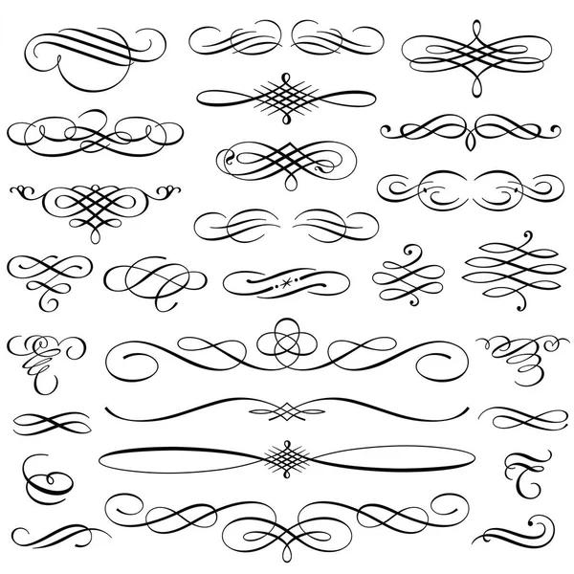
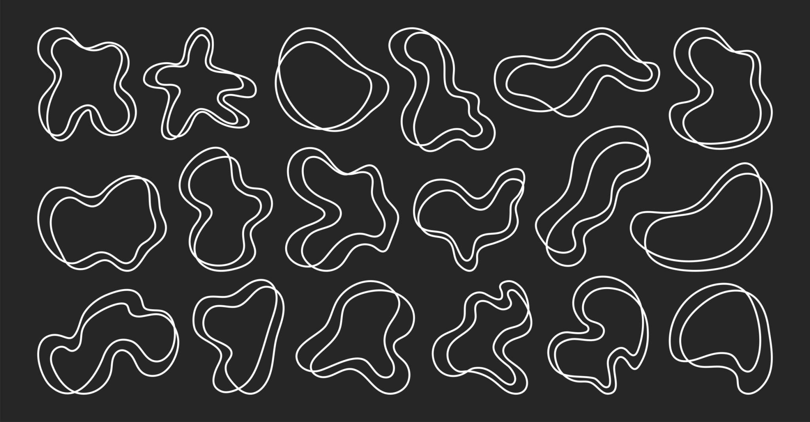
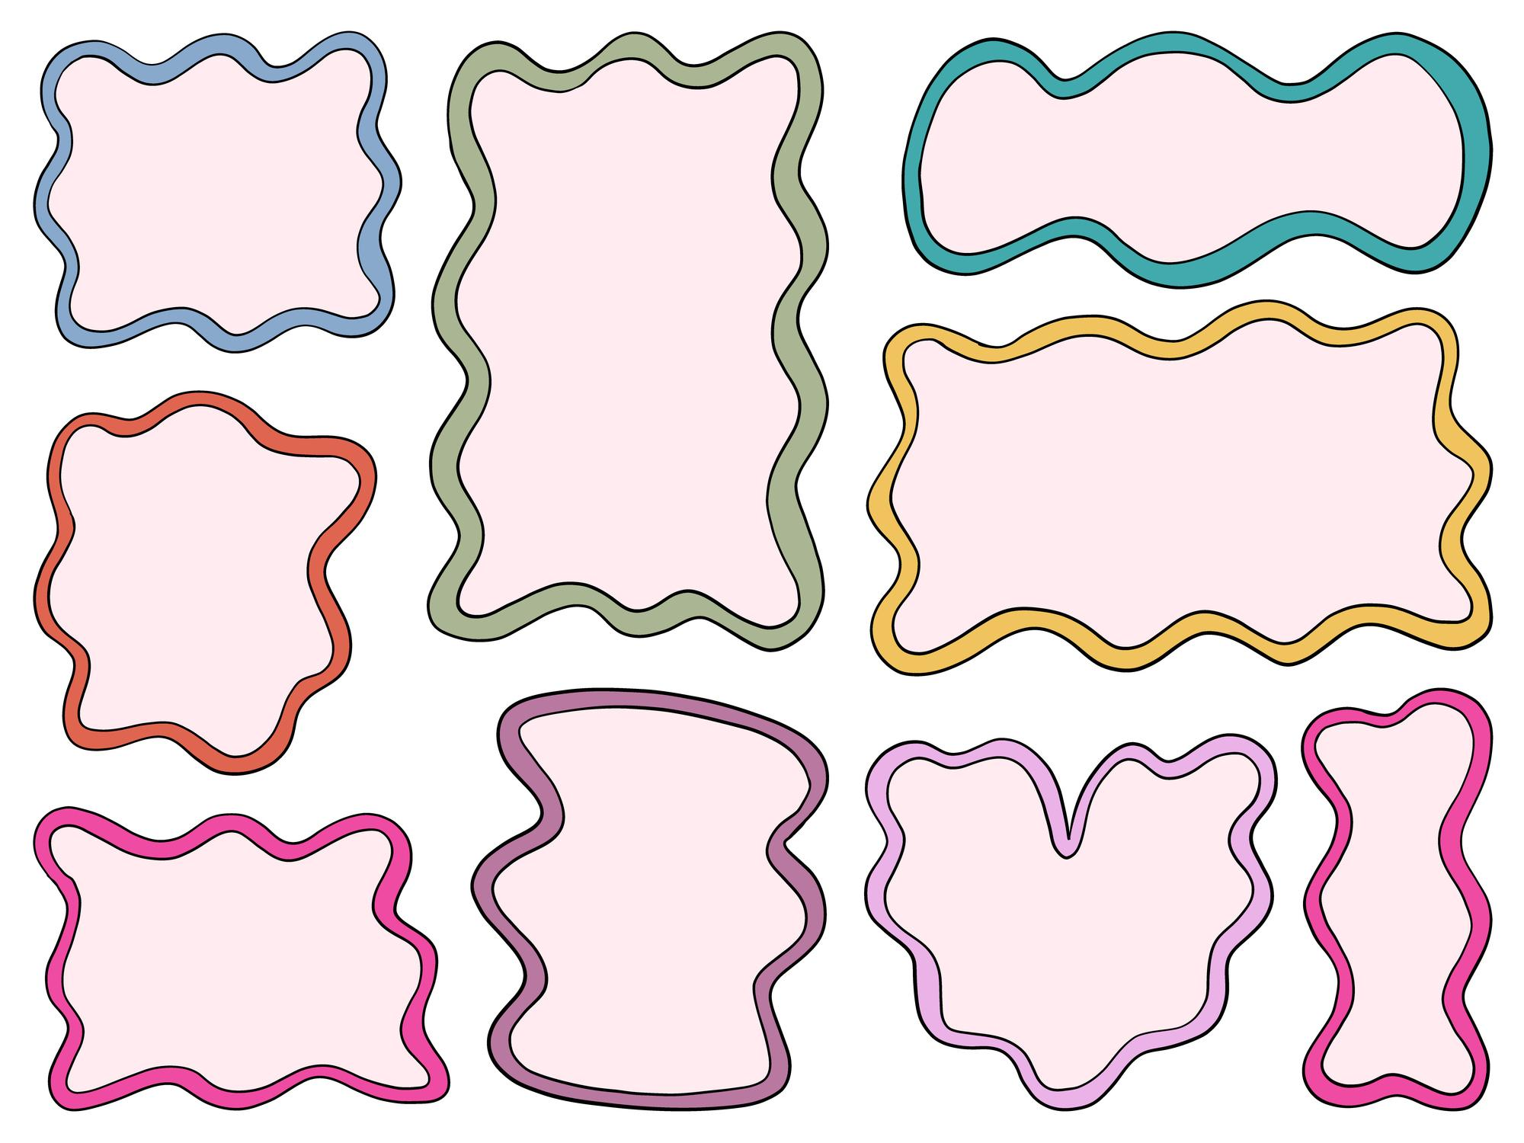
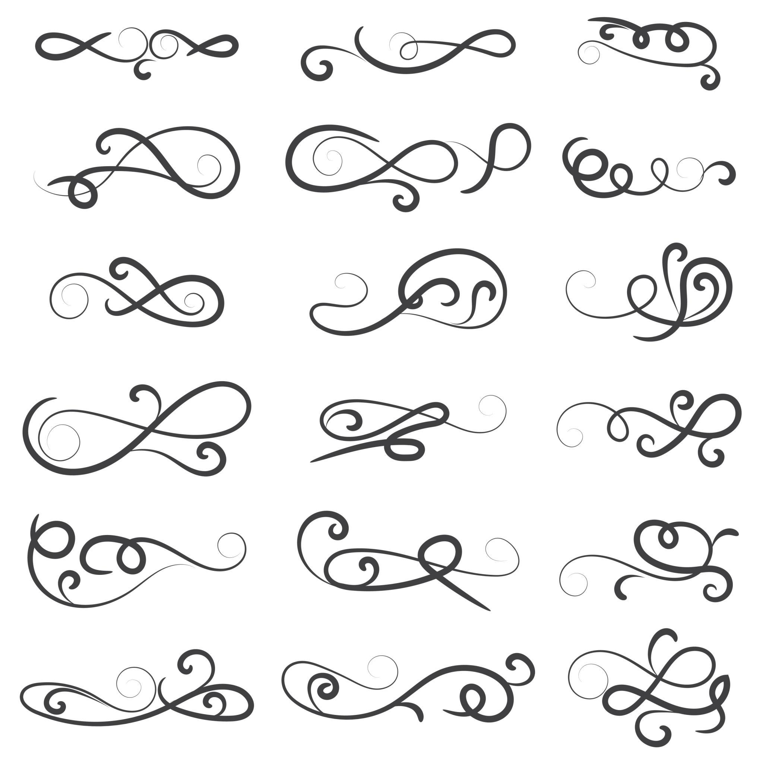
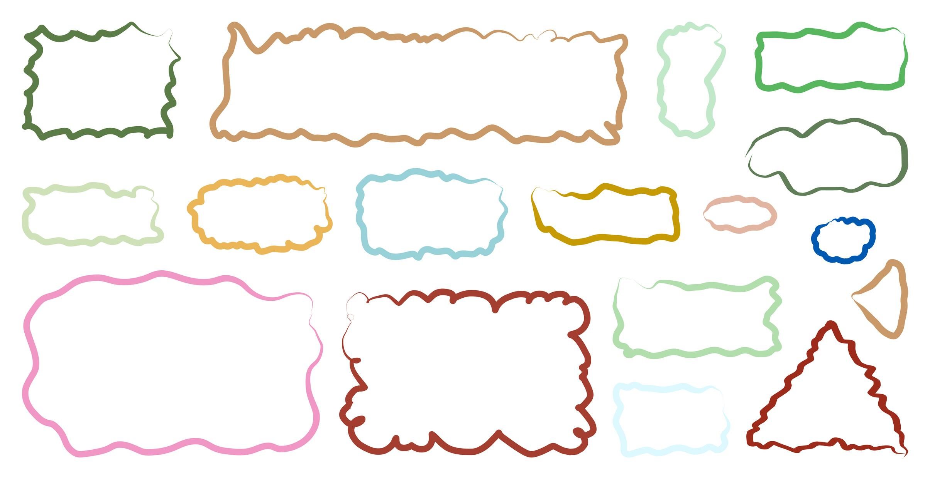
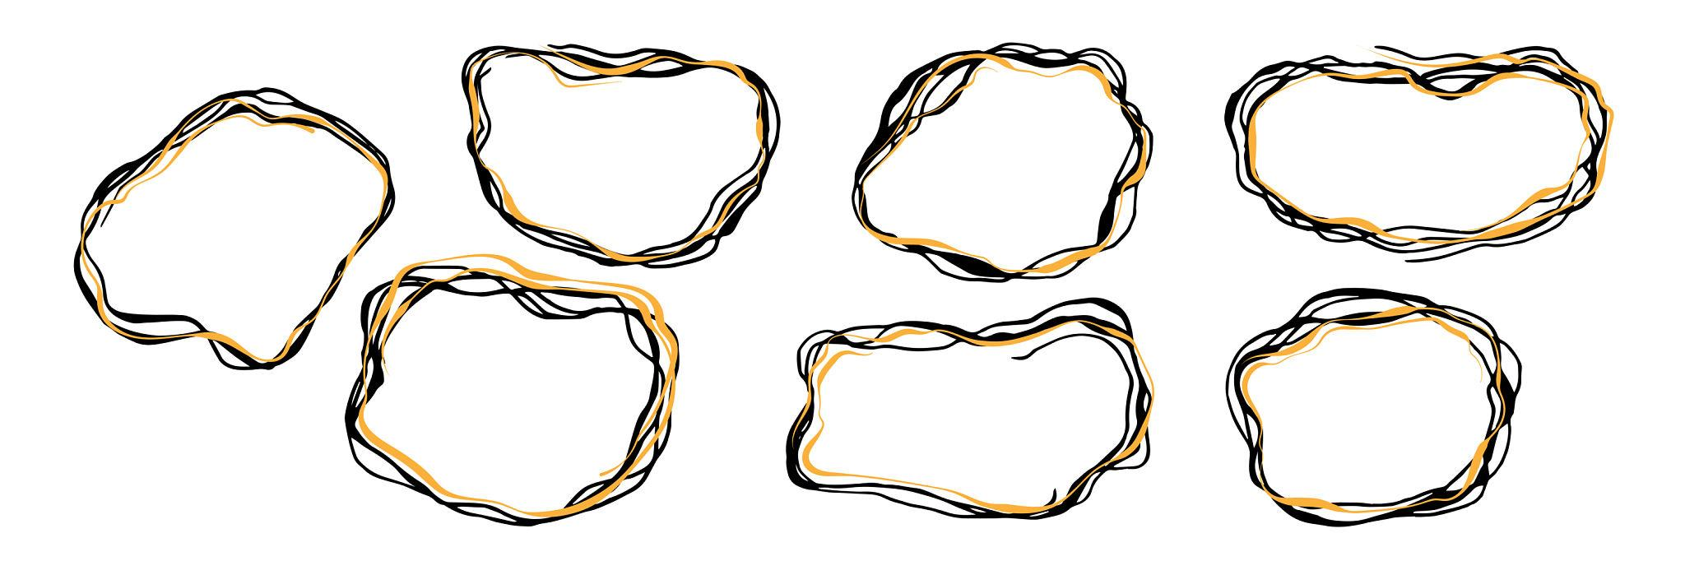

Symmetry in Decorative Freeform Shapes
# Source: AI Source: Provided by: [Data Path: Persons Table -> ID Column: 1, Name_En Column: Motasem Essam] -> From: [ChatGPT] on [7/25/2026]
Symmetry is particularly common in decorative design.
A Decorative Freeform Shape may have:
Reflection Symmetry
The shape remains unchanged after reflection:
$$R\left(S\right)=S$$
Rotational Symmetry
The shape remains unchanged after rotation through a specific angle:
$$T_{θ}\left(S\right)=S$$
Point Symmetry
The shape remains unchanged under a ${180}^{∘}$rotation about a point.
Asymmetry
The design does not remain unchanged under the symmetry transformation being considered:
$$T\left(S\right)≠S$$
A decorative freeform shape does not have to be symmetric.

Repetition and Decorative Patterns
# Source: AI Source: Provided by: [Data Path: Persons Table -> ID Column: 1, Name_En Column: Motasem Essam] -> From: [ChatGPT] on [7/25/2026]
Decorative Freeform Shapes are often used as motifs.
A single motif can be transformed repeatedly:
Motif → Motif → Motif → Motif → Motif
Common transformations include:
- Translation
- Rotation
- Reflection
- Scaling
A rotational arrangement can be represented by:
$$θ_{k}=θ_{0}+k\frac{2π}{n}$$
where $n$is the number of repeated copies.
This can produce circular decorative arrangements.

Mathematical Representation
# Source: AI Source: Provided by: [Data Path: Persons Table -> ID Column: 1, Name_En Column: Motasem Essam] -> From: [ChatGPT] on [7/25/2026]
Decorative Freeform Shapes can still be mathematically described even though their classification is primarily visual.
Parametric representation
$$r\left(t\right)=\left(x , \left(t\right)y\left(t\right)\right)$$
Piecewise representation
A complex decorative boundary can be represented as:
$$r\left(t\right)=\left\{\begin{matrix}r_{1}\left(t\right), & a≤t<c \\ r_{2}\left(t\right), & c≤t<d \\ r_{3}\left(t\right), & d≤t≤e\end{matrix}\right.$$
Different portions may represent different curves or line segments.

Perimeter and Area
# Source: AI Source: Provided by: [Data Path: Persons Table -> ID Column: 1, Name_En Column: Motasem Essam] -> From: [ChatGPT] on [7/25/2026]
For a closed decorative freeform shape, the boundary length can be represented by:
$$L=\int_{a}^{b}{\sqrt{{\left(\frac{dx}{dt}\right)}^{2}+{\left(\frac{dy}{dt}\right)}^{2}}} dt$$
If the boundary is made from separate straight and curved sections:
$$P=\sum{L_{\text{straight}}}+\sum{L_{\text{curved}}}$$
For a closed smooth boundary, the enclosed area can be expressed as:
$$A=\frac{1}{2}\oint{(}\left.x dy-y dx\right)$$
Thus, a shape can be decorative in purpose while still having measurable mathematical properties.

Decorative Freeform Shapes vs Other Freeform Shapes
# Source: AI Source: Provided by: [Data Path: Persons Table -> ID Column: 1, Name_En Column: Motasem Essam] -> From: [ChatGPT] on [7/25/2026]
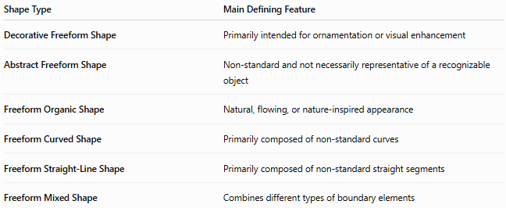
Shape Type | Main Defining Feature
Decorative Freeform Shape | Primarily intended for ornamentation or visual enhancement
Abstract Freeform Shape | Non-standard and not necessarily representative of a recognizable object
Freeform Organic Shape | Natural, flowing, or nature-inspired appearance
Freeform Curved Shape | Primarily composed of non-standard curves
Freeform Straight-Line Shape | Primarily composed of non-standard straight segments
Freeform Mixed Shape | Combines different types of boundary elements
Important distinction
These categories describe different aspects of a shape.
For example, one shape can be:
Decorative + Freeform + Organic + Symmetric
Another can be:
Decorative + Freeform + Abstract + Asymmetric
Therefore, these categories should not always be treated as mutually exclusive.

Decorative vs Abstract
# Source: AI Source: Provided by: [Data Path: Persons Table -> ID Column: 1, Name_En Column: Motasem Essam] -> From: [ChatGPT] on [7/25/2026]
Decorative describes the purpose or use of a shape.
Abstract describes its representational character.
Therefore:
$$\text{Decorative}≠\text{Abstract}$$
A decorative shape can represent a recognizable flower, while an abstract shape can be purely artistic without being intended as decoration.

Decorative vs Organic
# Source: AI Source: Provided by: [Data Path: Persons Table -> ID Column: 1, Name_En Column: Motasem Essam] -> From: [ChatGPT] on [7/25/2026]
Organic describes the appearance or form of a shape.
Decorative describes its intended visual function.
Therefore, a shape can be:
- Organic but not decorative
- Decorative but not organic
- Both organic and decorative
For example, a natural leaf is organic but is not necessarily a decorative shape. A stylized leaf used in an ornamental border can be both.

Examples

Example 1 — Decorative Flourish
# Source: AI Source: Provided by: [Data Path: Persons Table -> ID Column: 1, Name_En Column: Motasem Essam] -> From: [ChatGPT] on [7/25/2026]
A flowing curved line used to decorate a page or frame.

Example 2 — Floral Ornament
# Source: AI Source: Provided by: [Data Path: Persons Table -> ID Column: 1, Name_En Column: Motasem Essam] -> From: [ChatGPT] on [7/25/2026]
A freeform arrangement inspired by petals and leaves.

Example 3 — Decorative Border
# Source: AI Source: Provided by: [Data Path: Persons Table -> ID Column: 1, Name_En Column: Motasem Essam] -> From: [ChatGPT] on [7/25/2026]
A freeform motif repeated along the edge of a design.

Example 4 — Abstract Ornament
# Source: AI Source: Provided by: [Data Path: Persons Table -> ID Column: 1, Name_En Column: Motasem Essam] -> From: [ChatGPT] on [7/25/2026]
An irregular collection of curves and lines designed purely for visual effect.

Example 5 — Decorative Frame
# Source: AI Source: Provided by: [Data Path: Persons Table -> ID Column: 1, Name_En Column: Motasem Essam] -> From: [ChatGPT] on [7/25/2026]
A closed freeform boundary surrounding another object or region.

Classification Summary
# Source: AI Source: Provided by: [Data Path: Persons Table -> ID Column: 1, Name_En Column: Motasem Essam] -> From: [ChatGPT] on [7/25/2026]
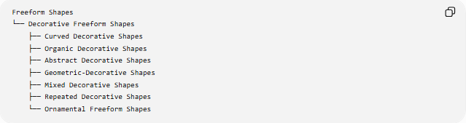
Freeform Shapes
└── Decorative Freeform Shapes
├── Curved Decorative Shapes
├── Organic Decorative Shapes
├── Abstract Decorative Shapes
├── Geometric-Decorative Shapes
├── Mixed Decorative Shapes
├── Repeated Decorative Shapes
└── Ornamental Freeform Shapes
A structural classification can also be represented as:
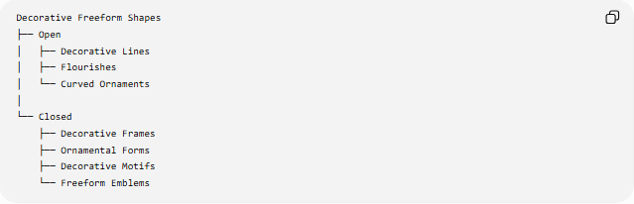
Decorative Freeform Shapes
├── Open
│ ├── Decorative Lines
│ ├── Flourishes
│ └── Curved Ornaments
│
└── Closed
├── Decorative Frames
├── Ornamental Forms
├── Decorative Motifs
└── Freeform Emblems
These classifications can overlap.
For example:
Closed + Decorative + Freeform + Organic + Symmetric + Repeated
is a valid combination.

Key Points
# Source: AI Source: Provided by: [Data Path: Persons Table -> ID Column: 1, Name_En Column: Motasem Essam] -> From: [ChatGPT] on [7/25/2026]
- Decorative Freeform Shapes are primarily designed for visual or ornamental purposes.
- They do not follow one fixed standard geometric form.
- They may contain curves, straight lines, organic elements, or abstract elements.
- They can be open or closed.
- They may be symmetric, asymmetric, or partially symmetric.
- Decorative motifs can be repeated using translation, rotation, reflection, or scaling.
- A decorative shape can still have mathematically measurable length, area, curvature, and coordinates.
- Decorative describes the purpose or visual function.
- Freeform describes the lack of a predetermined standard geometric structure.
- Decorative, abstract, and organic are not mutually exclusive categories.
- This is primarily a descriptive classification, rather than a strict universal mathematical shape class.

Conclusion
# Source: AI Source: Provided by: [Data Path: Persons Table -> ID Column: 1, Name_En Column: Motasem Essam] -> From: [ChatGPT] on [7/25/2026]
A Decorative Freeform Shape is a non-standard shape designed primarily to provide ornamentation, visual enhancement, or aesthetic expression. It can combine geometric, organic, abstract, curved, and straight-line elements and can be used individually or as repeated decorative motifs.

